Phase 2

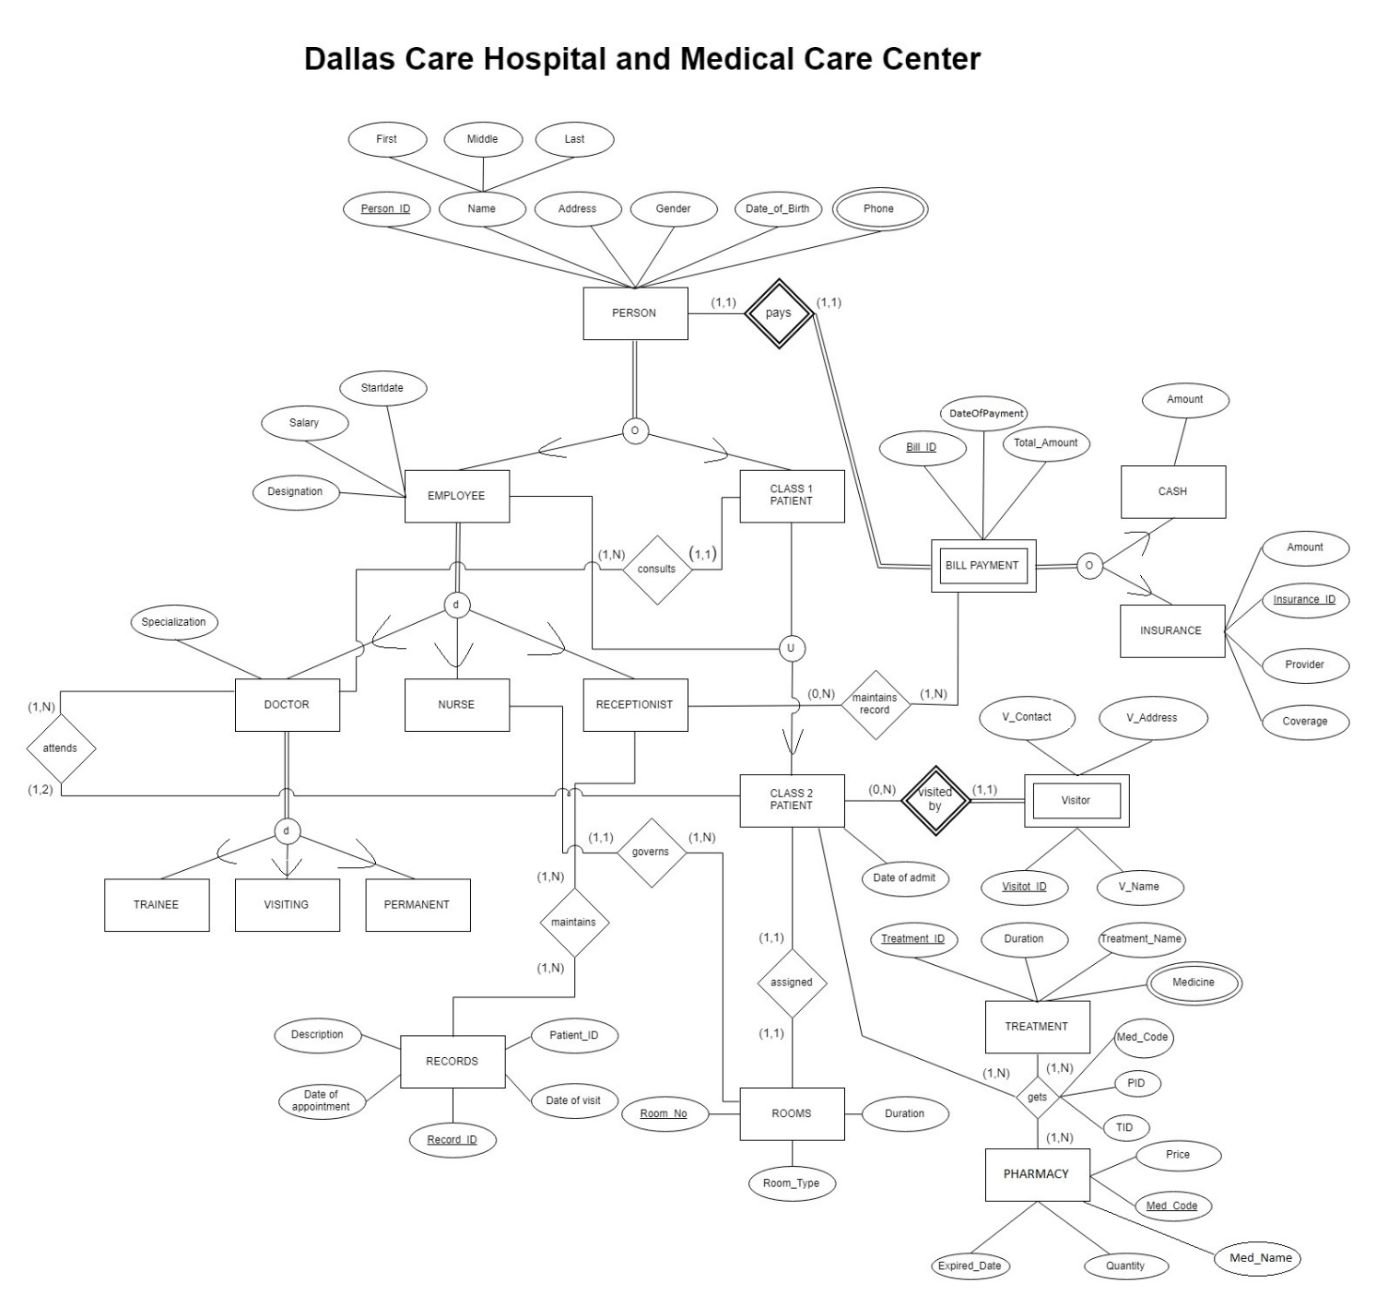

Assumptions:

|  |
| --- |
| 1. Names are not more than 20 characters |
| 1. Address is not more than 200 characters |
| 1. Id of all persons is not greater than 4 characters (they may include numbers also) |
| 1. Salary is of 10 numbers with 2 decimal points |
| 1. Phone number is of 11 digits |
| 1. Description is not more than 200 characters |
| 1. Specialization is not more than 20 characters |
| 1. Roomno is not more than 10 digits |
| 1. Duration can be a maximum of 5 digits |
| 1. Amount and TotalAmountDue can be a maximum of 10 digits with 2 decimal places |
| 1. Recordid, Medicinecode, Treatmentid, Billid, Insuranceid cannot be more than 20 characters |

|  |  |  |  |  |  |  |  |  |  |  |  |
| --- | --- | --- | --- | --- | --- | --- | --- | --- | --- | --- | --- |
| Relations | Attributes | | | | | | |  | Foreign key attributes | | |
| PERSON | Personid (VARCHAR2(4)) | FirstName (VARCHAR2(20[CHAR])) | MiddleName (VARCHAR2(20[CHAR])) | LastName (VARCHAR2(20[CHAR])) | Address (VARCHAR2(200 )) | Gender (VARCHAR26 [CHAR])) | DateOfBirth (DATE) |  |  |  |  |
| PERSON_PHONE | Personid (VARCHAR2(4)) | Phone (NUMBER(11) |  |  |  |  |  |  | Personid references PERSON (Personid) |  |  |
| EMPLOYEE | Employee_Personid (VARCHAR2(4)) | Salary (NUMBER(10,2) | StartDate (DATE) | Designation (VARCHAR2(200 [CHAR])) | Class2_Personid (VARCHAR2(4)) |  |  |  | Employee_Personid references PERSON (Personid) | Class2_Personid references CLASS2_PATIENT(Class2_Personid) |  |
| CLASS1_PATIENT | Class1_Personid (VARCHAR2(4)) | Class2_Personid (VARCHAR2(4) [CHAR]) | Doctor_personid (VARCHAR2(4)) |  |  |  |  |  | Class1_personid references PERSON(Personid) | Doctor_Personid references DOCTOR(Doctor_personid) | Class2_Personid references CLASS2_PATIENT(Class2_Personid) |
| DOCTOR | Doctor_personid (VARCHAR2(4)) | Specialization (VARCHAR2(20 [CHAR])) |  |  |  |  |  |  | Doctor_Personid references PERSON(Personid) |  |  |
| NURSE | Nurse_personid (VARCHAR2(4)) |  |  |  |  |  |  |  | Nurse_Personid references PERSON(Personid) |  |  |
| RECEPTIONIST | Receptionist_Personid (VARCHAR2(4)) |  |  |  |  |  |  |  | Receptionist_personid references PERSON(Personid) |  |  |
| TRAINEE | Trainee_Personid (VARCHAR2(4)) |  |  |  |  |  |  |  | Trainee_Personid references PERSON(Personid) |  |  |
| VISITING | Visiting_Personid (VARCHAR2(4)) |  |  |  |  |  |  |  | Visiting_Personid references PERSON(Personid) |  |  |
| PERMANENT | Permanent_Personid (VARCHAR2(4)) |  |  |  |  |  |  |  | Permanent_Personid references PERSON(Personid) |  |  |
| CLASS2_PATIENT | Class2_Personid (VARCHAR2(4)) | Doctor_Personid (VARCHAR2(4)) | RoomNo (Number (10) |  |  |  |  |  | Class2_Personid references PERSON(Personid) | Doctor_Personid references DOCTOR(Doctor_personid) | RoomNo references ROOMS(RoomNo) |
| ROOMS | RoomNo (Number 10) | RoomType (VARCHAR2(20[CHAR])) | Duration NUMBER(5) | Nurse_Personid (VARCHAR2(4)) |  |  |  |  | Nurse_Personid references NURSE(Nurse_Personid) |  |  |
| RECORDS | Recordid (VARCHAR2(20)) | DateOfAppointment DATE | DateOFVisit (DATE) | Description (VARCHAR2(100)) | Patientid |  |  |  | Patientid references CLASS1_PATIENT(CLass1_Personid) |  |  |
| PHARMACY | MedicineCode (VARCHAR2(20)) | MedicineName (VARCHAR2(20)) | MedicinePrice NUMBER(10) | Quantity NUMBER(5) | DateOfExpiry (DATE) |  |  |  |  |  |  |
| TREATMENT | Treatmentid (VARCHAR2(20)) | TreatmentName (VARCHAR2(20[CHAR)) | Duration NUMBER(5) |  |  |  |  |  |  |  |  |
| TREATMENT_MEDICINE | Treatmentid (VARCHAR2(20)) | MedicineList (VARCHAR2(20)) |  |  |  |  |  |  | Treatmentid references TREATMENT(Treatmentid) |  |  |
| VISITOR | Visitorid (VARCHAR2(20)) | Class2_Personid (VARCHAR2(4)) | Name (VARCHAR2(20[CHAR])) | Address (VARCHAR2(200)) | Contact (NUMBER(11)) |  |  |  | Class2_Personid references CLASS2_PATIENT(Class2_Personid) |  |  |
| BILLPAYMENT | Billid (VARCHAR2(20)) | Personid (VARCHAR2(4)) | DateOfPayment (DATE) | TotalAmountDue NUMBER(10,2) |  |  |  |  | Personid references PERSON (Personid) |  |  |
| CASH | Billid (VARCHAR2(20)) | Personid (VARCHAR2(4)) | Amount NUMBER(10,2) |  |  |  |  |  | Billid references BILLPAYMENT(Billid) | Personid references PERSON (Personid) |  |
| INSURANCE | Insuranceid (VARCHAR2(20)) | Billid (VARCHAR2(20)) | Personid (VARCHAR2(4)) | Amount NUMBER(10,2) | Provider (VARCHAR2(20)) | Coverage (VARCHAR2(20)) |  |  | Billid references BILLPAYMENT(Billid) | Personid references PERSON (Personid) |  |
| MAINTAINS | Recordid (VARCHAR2(20)) | Receptionist_Personid (VARCHAR2(4)) |  |  |  |  |  |  | Record references RECORDS(Recordid) | Receptionist_personid references RECEPTIONIST(Receptionist_personid) |  |
| MAINTAINS_PAYMENT | Receptionist_Personid (VARCHAR2(4)) | Billid (VARCHAR2(20)) |  |  |  |  |  |  | Receptionist_personid references RECEPTIONIST(Receptionist_personid) | Billid references BILLPAYMENT(Billid) |  |
| GETS | MedicineCode (VARCHAR2(20)) | Treatmentid (VARCHAR2(20)) | Class2_Personid (VARCHAR2(4)) |  |  |  |  |  | MedicineCode references PHARMACY(MedicineCode) | Treatmentid references TREATMENT(Treatmentid) | Class2_Personid references CLASS2_PATIENT(Class2_Personid) |

**Steps for Mapping**

Step 1: Create a new relation for each strong entity type(PERSON, EMPLOYEE, CLASS1_PATIENT, DOCTOR,NURSE, RECEPTIONIST, CLASS2_PATIENT, TRAINEE, VISITING, PERMANENT, RECORDS, ROOMS, MEDICINE, TREATMENT, INSURANCE, CASH) in the EER diagram and include all the attributes into the new relation.

Step 2: If there are any weak entities(VISITOR, BILLPAYMENT) in the ER diagram, then create a new relation with all the attributes of this entity and the primary key of its owner entity as a foreign key.

Step 3: For each 1:1 relationship type, select one relation(those having total participation) and add the primary key of the other relation as its foreign key. Also, add all the attributes of the relationship type to this relation. (assigned, pays)

Step 4: For each 1:N relationship type(attends, governs, consults visitedby), select one relation at the N-side and add the primary key of the other relation as the foreign key. Also, add all the attributes of the relationship type to this relation.

Step 5: For each M:N relationship type(maintains, maintainsrecord, ) , create a new relation with the primary keys of the two participating relations as its foreign key attributes and also add any simple attributes of the relationship type.

Step 6: For each multivalued attribute for an entity (Phone, MedicineList), create a new relation with the multivalued attribute and the primary key of that relation. (PERSON_PHONE,TREATMENT_MEDICINE)

Step 7: If there is an n-ary relationship type (gets), create a new relation with all the primary keys of the participating relations as their foreign keys and add other simple attributes of the relationship type if any. (GETS)

Step 8: If there is a specialization or generalization ((PERSON (overlapping)- EMPLOYEE, CLASS1_PATIENT) (EMPLOYEE(disjoint)- DOCTOR, NURSE, RECEPTIONIST) (DOCTOR (disjoint)- TRAINEE,VISITING,PERMANENT), (BILLPAYMENT(overlapping)- CASH, INSURANCE) )in the ER diagram, then create a new relation for the superclass with all its attributes, then create new relations for each of its subclasses with their simple attributes and also add the primary key of the superclass as the primary key of the subclasses.

Step 9: If there is a union type(EMPLOYEE ,CLASS1_PATIENT- CLASS2_PATIENT) , add a surrogate key(Class2_Personid) to the relation that represents the defining superclass. And create new relations for each of its defining classes with their simple attributes and also add the surrogate key as their foreign key.